Sir Syed University of Engineering & Technology (SSUET)

Department of Software Engineering

Course Name: Artificial Intelligence (SE-314L)
Semester: 5th
Batch: 2023F
Section: “C”

PROJECT REPORT

Project Title: ______________________________


Submitted To:
Dr. Muhammad Naseem
Dr. Engr. Farheen Qazi
Engr. Dur-e-Shawar Agha
Engr. Samrah Shafiq

Submitted By:
STUDENT’S NAME 2023F-SE-__
STUDENT’S NAME 2023F-SE-__
STUDENT’S NAME 2023F-SE-__
STUDENT’S NAME 2023F-SE-__

TABLE OF CONTENTS
S. No. | TOPICS | PAGE No.
1 | PROBLEM DOMAIN
2 | PROPOSED TREATMENT
3 | PLAN OF WORK
4 | PROJECT SCHEDULING
5 | SOFTWARE AND HARDWARE SPECIFICATIONS
6 | BLOCK DIAGRAM
7 | SYSTEM FLOW DIAGRAM
8 | USER GUIDE

TEAM PROFILE

- STUDENT NAME (2023F-SE-__)
(Mention your role in the project)

- STUDENT NAME (2023F-SE-__)
(Mention your role in the project)

- STUDENT NAME (2023F-SE-__)
(Mention your role in the project)

- STUDENT NAME (2023F-SE-__)
(Mention your role in the project)

1. PROBLEM DOMAIN
Description of the project that is being developed, its context and the need that triggered the development effort, as well as the objectives of the project that need to be accomplished.
OR
Description of the project that is being referring to all information that defines the problem and constrains the solution (the constraints being part of the problem). It includes the goals that the problem owner wishes to achieve, the context within which the problem exists, and all rules that define essential functions or other aspects of any solution product. It represents the environment in which a solution will have to operate, as well as the problem itself.

2. PROPOSED TREATMENT
Identify the ways through which the required objectives of the project will be met. Describe the solution that you have proposed in order to solve the stated problem.

3. PLAN OF WORK
Description of how you will carry out all the project activities. For example, conducting research, dividing the project into multiple tasks and assigning to team members, etc.

4. PROJECT SCHEDULING
Make a Gantt chart, showing your project schedule including task names and the time allotted to each task. Attach screenshots of your Gantt chart.
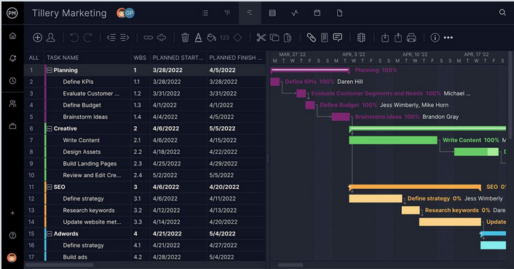
Figure 4.1: Sample Gantt Chart
OR
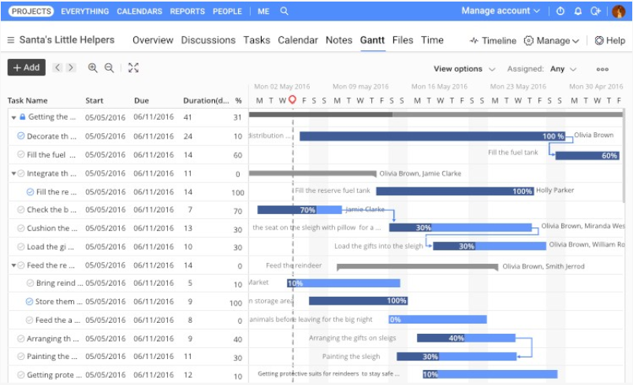
Figure 4.2: Sample Gantt Chart

5. SOFTWARE AND HARDWARE SPECIFICATIONS
Mention all the tools and Softwares that have been used in the development of the project. Also describe the hardware specifications required for the project.
This project describes the following requirements:
- Hardware Requirements:
  - Processor: Minimum 1 GHz; Recommended 2GHz or more
  - Ethernet connection (LAN) OR a wireless adapter (Wi-Fi)
  - Hard Drive: Minimum 32 GB; Recommended 64 GB or more
  - Memory (RAM): Minimum 1 GB; Recommended 4 GB or above
  - Sound card w/speakers
  - Some classes require a camera and microphone

- Software Requirements:
  - Operating system
  - SharePoint Server 2013
  - SQL Server
  - Requirements for Project Server 2013 features

6. BLOCK DIAGRAM
Below is a sample block diagram. Make one for your project that should clarify overall concepts of your project. The principal parts or functions should be represented by blocks connected by lines that show the relationships of the blocks.

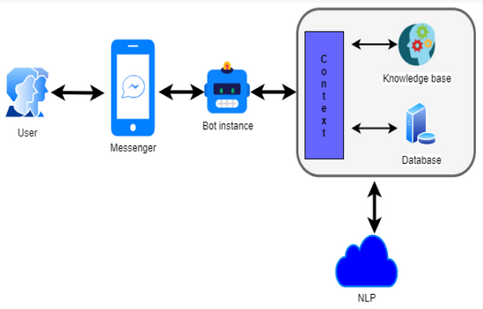
Figure 6.1: Sample Block Diagram

7. SYSTEM FLOW DIAGRAM

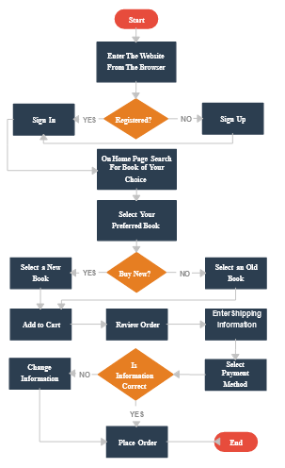
Figure 7.1: Sample System Flow Diagram

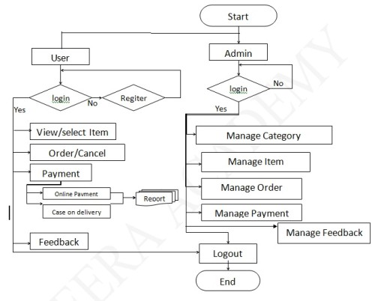
Figure 7.2: Sample System Flow Diagram

8. USER GUIDE
Explain through screenshots, how the end users will interact with your developed project. Describe the whole process step by step.

1. How to set up a chatbot
The first thing your chatbot will need is a name. To configure your chatbot, go to Settings > General and edit the default name of your bot.
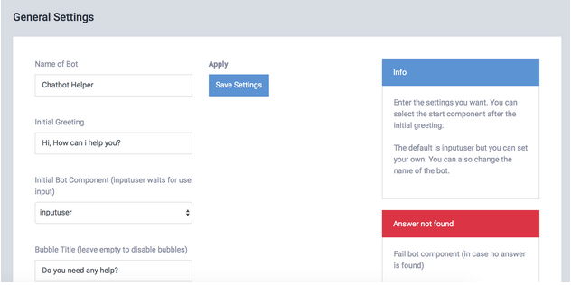
You can also change the notification message (bubble pop-up) to a personalized message for your site that can attract more clicks and interactions with your bot.

2. How to add your answers
To train your chatbot with your answers you have three options.
- Use your own pairs of questions and answers
- Load a Subject
- Import your Questions and Answers
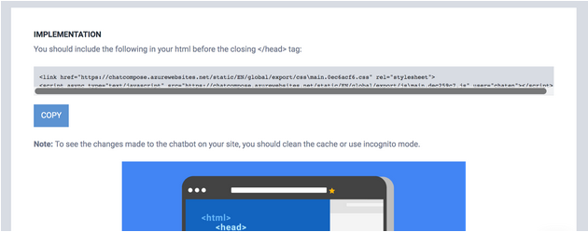

3. Leads and Contacts
ChatCompose allows you to capture or save important data using the form component. Using these components, you can make inquiries to your users and save this data in the Leads section.
Each time a user executes or terminates a form component, their data will be saved in a sheet format so that you can see it in the Leads section.
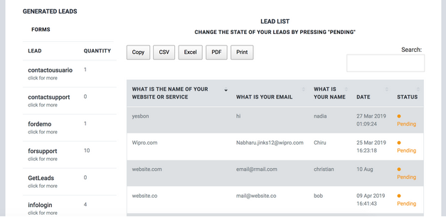
This data will appear in the Leads section with the name of the form. You can use this component to save survey data, qualified leads, purchase orders and support or contact requests.

4. Page Configuration
You can create an individual configuration for your chatbot to appear on specific pages using this option.
If you need to give a different name to your bot, or load a specific script for a section of your site you can configure these options in Settings > Pages.
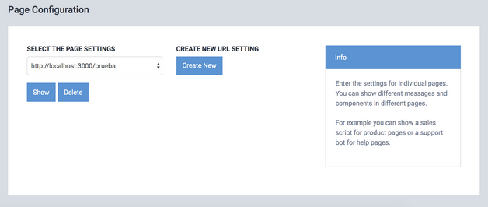
You only need to press "Create new" and complete the form to install it.
For example, if you want to load a simple contact script for the contact section of your site, create the script, and set it as an initial component for that url.

5. How to use the panel
Each bot and ChatCompose account has its own panel and its own navigation bar.
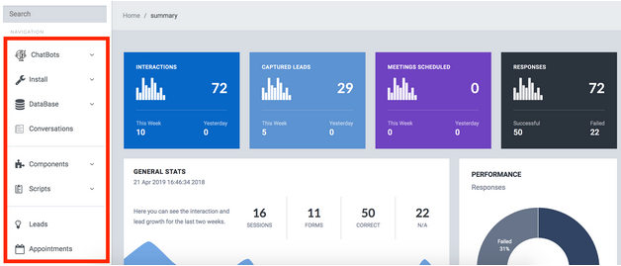

REFERENCES
Include all references here.

INSTRUCTIONS

- You have to implement AI based algorithms or libraries in your project.
- Try to implement the project on your own, must not be cheat or copy from anywhere and must believe that you will achieve the target!
- The font size should be 14 for heading and 12 for the rest of text, font style should be Times New Roman. The font color should be black only.
- The header must contain the heading “Artificial Intelligence Project Report” in the middle and the footer must contain the heading “SIR SYED UNIVERSITY OF ENGINEERING AND TECHNOLOGY” on left side and page numbers on the right side through out in the report. The page number should start from “Problem Domain”.
- There can be only single line spacing between the lines.

